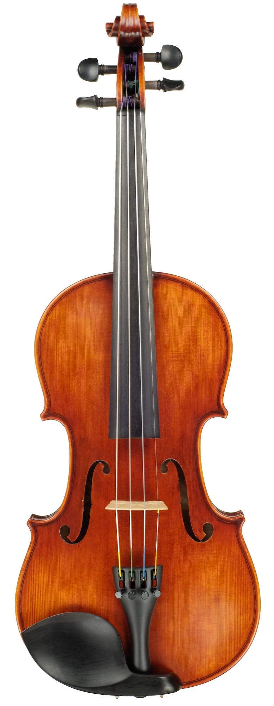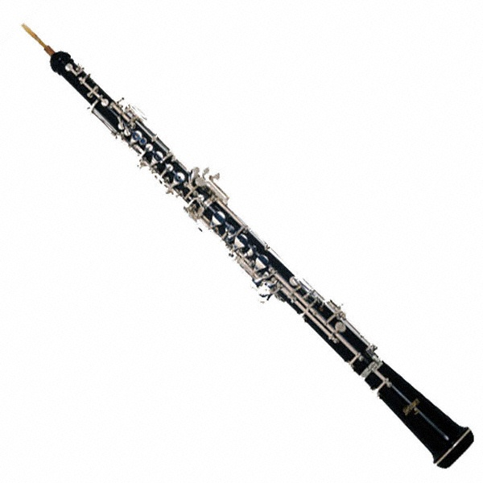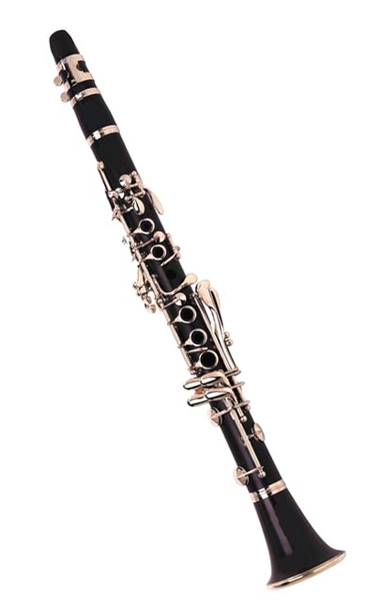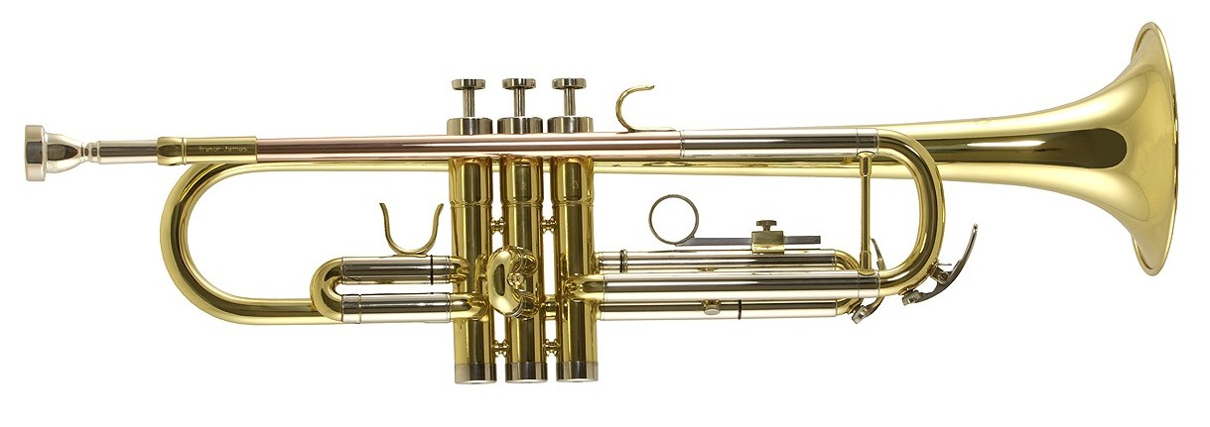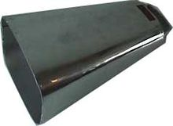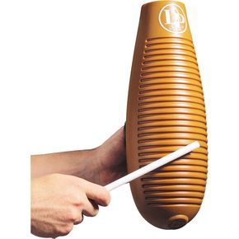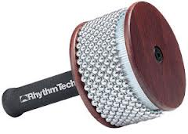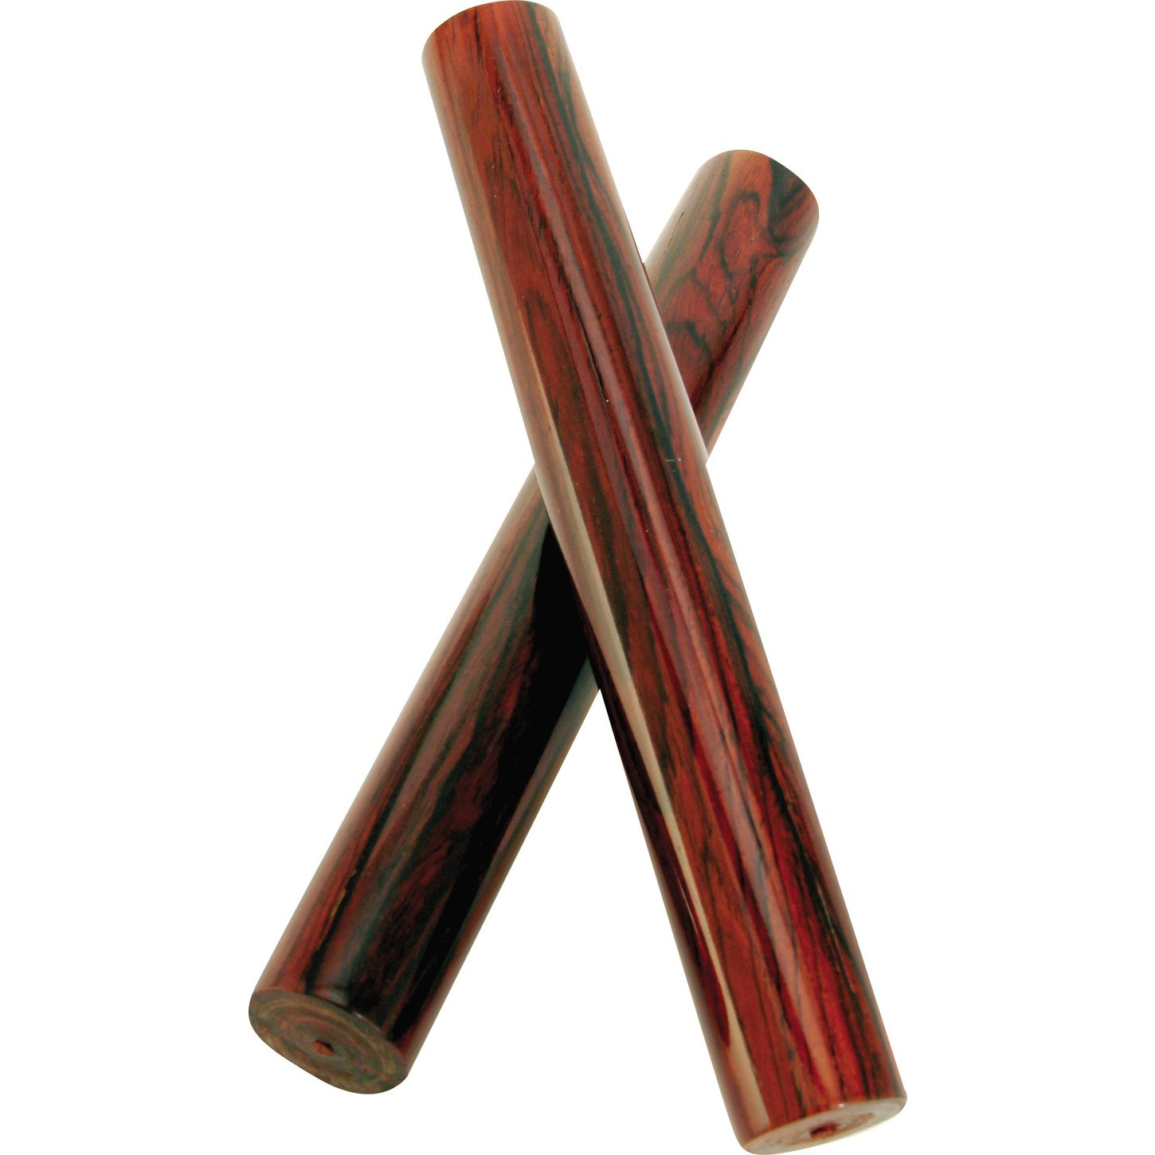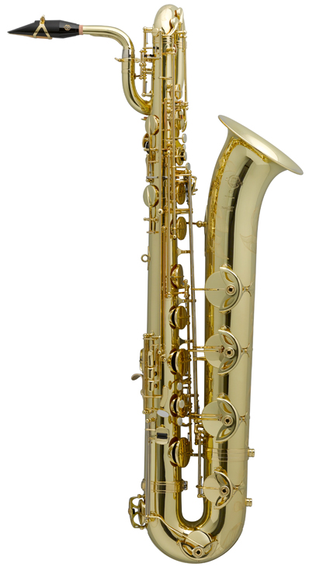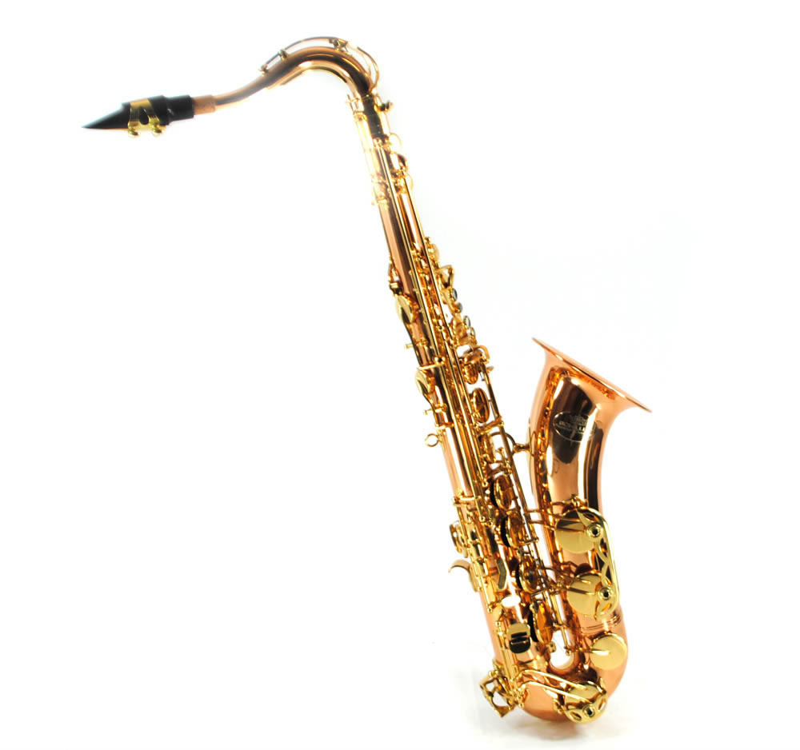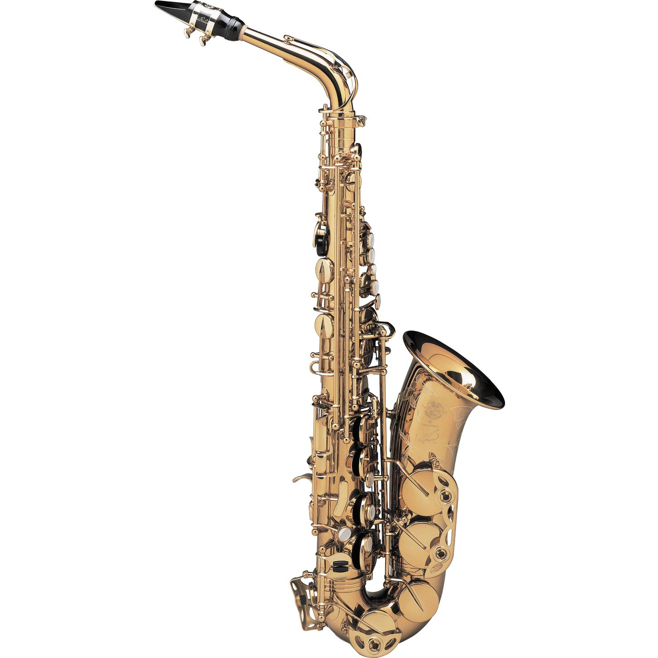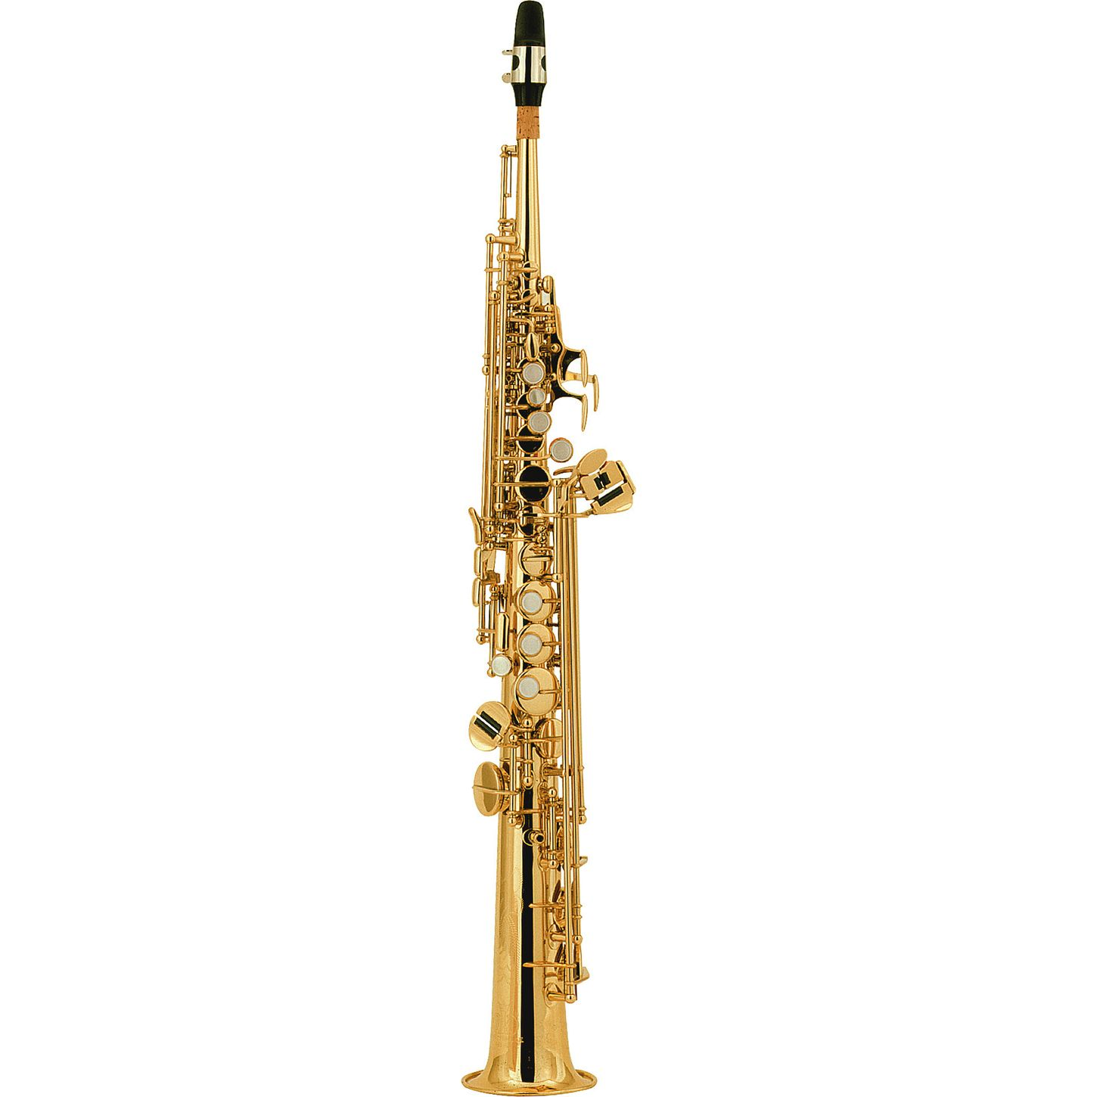

Section 1.

**‘ALL sound only ever occurs when there is some type of vibration at the beginning’.**

a) Name the 4 Different Families of the Orchestra .

1. ___________

2. ___________

3. ___________

4. ___________

b) Please circle.

The longer or bigger an instrument is, the **lower/higher** the sound is.

Tuning pegs -

Fingerboard -

F Holes -

Bridge -

___/3

Section 2.

a) **Violin** is the highest sounding instrument in its family. Name the other three instruments from highest to lowest sound.

1. Violin 2. ____________ 3.______________ 4.____________

b) What are two different ways these instruments can be played?

1.________________ 2. _________________

c) Without using your left hand to press down any extra notes, how many notes can you play on a violin? ____________

d) I am member of the string family but I am the only one that has to be played sitting down. Which instrument am I? ______________________

___/11

Section 3.

a) Which member of the **BRASS** family is the leader and plays the highest sounding notes? ____________________

b) Name two ways that this instrument can change its pitch?

1. _________________________ 2. ___________________________

e) Please draw a line from the following parts of the violin to match the picture.

**Name:____________________**

**Form:_____**

**Instruments of the Orchestra**

Section 4b.

e) The creator of the very first saxophone was called, Adolf (…who?) ____________

(Clue: It’s not Hitler!)

___/7

Name: ______________

Reed: _______________

Name: ______________

Reed: _______________

Section 4a.

a) What is the special name given to the half sized flute played in the orchestra? __________

b) Which type of reed is **bigger** in size, a double reed or single reed? _____________

c) What is the largest instrument of the **double reed family** and can also play the lowest in the entire orchestra? ___________________

d) Label these two pictures with their correct name and what types of reed they have.

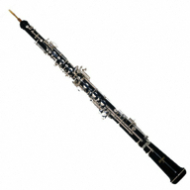

f) Label the following 4 parts of the Trumpet.

c) Which instrument is the largest in the brass family? __________________________

d) If you were to extend the slide on a trombone, what would happen to the pitch of the note, would it go up or down? ________________ why is this?_______________________________

_____________________________________________________________________________

e) Which brass instrument requires you to change the pitch of the notes with your left hand not your right? _________________________

2.____________

3.____________

4.____________

___/10

1.____________

Section 5.

a) The percussion family is the largest of the entire orchestra. True/false? ________

b) Name two ways that a percussion instrument is played to create its sound

1. __________________ 2. _________________

c) I am a tuned percussion instrument that is played by using different types of mallets. I am made mostly from wood but I have metal resonators. What instrument am I? _____________

d) What is the most commonly used un-tuned percussion instrument in almost all music made in the last 100 years? ____________________________

*(Clue: I have a metal rattle on my bottom skin that can be turned on and off.)*

e) I am a large, tuned percussion instrument that usually comes in groups of 4 and I am used to support the rhythm as well as the melody and harmony in orchestras? _________________

Please write the correct names underneath each un-tuned percussion instrument

___/4

2.____________

4.____________

3.____________

1._Soprano Sax

1.____________

Please Label these Saxophones with their correct names below.